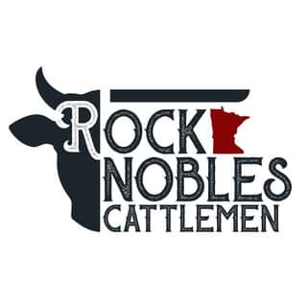

Rock/Nobles Cattlemens
Beef Ambassador Application
(Max of 2 year term)

The Rock/Nobles Youth Beef Ambassador Program is an opportunity for high school students in grades 10-12, both male and female, to represent the Rock and Nobles County Cattlemen at various events throughout the area and state during 2026. This is a great opportunity to help us promote beef to consumers within our surrounding communities!

2026 Beef Ambassador Application

Name:_______________________________________________________________________
Address: _______________________________ City: __________________ Zip: ___________
Phone: ____________________________ E-mail: ____________________________________
Parent(s)/Guardian(s): _________________________________________________________
High School: __________________________________________________________________
Graduation date: ______________________________________________________________
What is your career plan/goal after high school? (add additional pages, if necessary) ____________________________________________________________________________________________________________________________________________________________________________________________________________________________________________________________________________________________________________________

Why do you want to be a beef ambassador for Rock/Nobles County? (add additional pages, if necessary)
____________________________________________________________________________________________________________________________________________________________________________________________________________________________________________________________________________________________________________________
Provide additional information for the following on a separate sheet of paper if necessary

Extra-curricular activities:
1.
2.
3.
4.
5.

List involvement in organizations and any leadership roles:
1.
2.
3.
4.
5.

Applicant Signature: Date:

Parent/Guardian Signature: Date:

RETURN BY: January 9, 2026

RETURN TO: Rock/Nobles Cattlemen
Attn: Matt Widboom
22487 US Hwy 59N
Worthington, MN 56187
OR
E-MAIL TO: mwidboom@gmail.com

THANK YOU FOR YOUR INTEREST IN BEING A 2026 BEEF AMBASSADOR!!

